**PEGUIN ADVENTURE- COMPLETE GAME KIT**

1. **Introduce gameplay and features**
2. **Tutorial** 
   1. **Game Editor**
   2. **Game Controller**
   3. **Admob Ads: link download admob package: http://bit.ly/1ZxtkuL**
   4. **Introduce Monsters and other things**
   5. **Basic Tutorials**

**If you like this game, please review it, I appreciate it ;)**

**I. Introduce gameplay and features**

Let's take adventure and help a little cute Penguin against the alien monsters.

Simple gameplay, nice graphic, funny monsters and sound, very funny and very interesting, you can help him slide, jump, fire or even fly with a cannon or rocket,

WOW

**FEATURES:**

+ Nice sound and graphics

+ Classic platform game style

+ Simple gameplay, just tap and tap

+ Monetization with Admob integrated

+ Addictive gameplay

+ Total C#, Easy to play, easy to learn, easy to reskin

**II. TUTORIAL**

**1.**

**Game Editor**

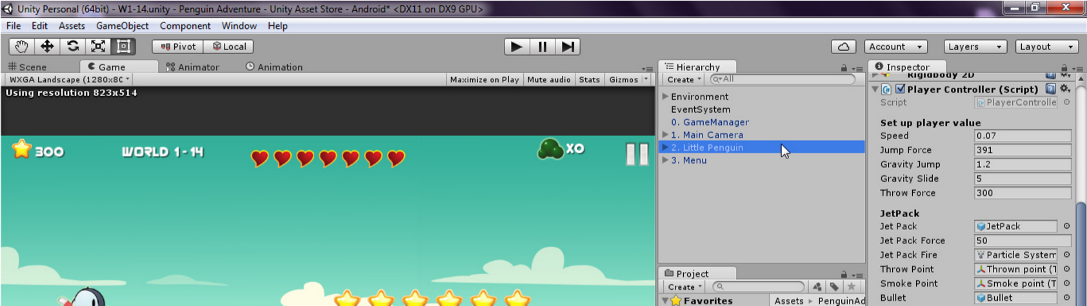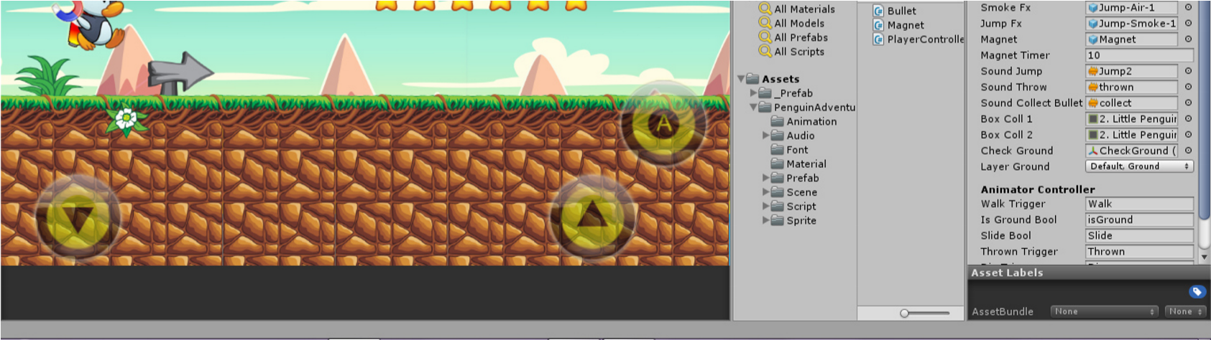

1. **Game Controller Main folder**:
   * **Animation:** Holds the animation clips made with Unity’s built-in animation system.
   * **Prefab:** Holds all the prefabs used in the game. These are distributed to various folders for easier access.
   * **Scenes**: The first scene that runs in the game is Menu. From this scene you can get to the Game scene and goto levels.
   * **Scripts**: Holds all the scripts used in the game. Each prefab contains one or more of these scripts.
   * **Audio**: Holds all the sounds used in the game. Jump, Click, etc
   * **Sprite**: Holds all the textures used in the game which are used as sprites in Unity.

**Main Controller gamplay:**

**a. Game Manager**

**GameManager** *script control game state, store score, best score and Fail function.*

*You can call the function directly.*

**Setup Level:**

* + - * + **Is Finish World:** check this if

this is the final level of the world to make the game unlock next world

* + - * + **Bullets:** how many bullet do you allow the player have to use in game
        + **Star 1:** scores needed to get 1

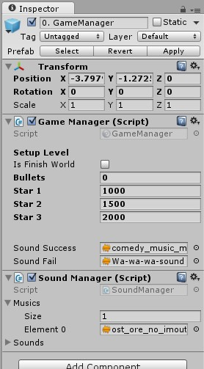star

* + - * + **Star 2:** scores needed to get 2

star

* + - * + **Star 3:** scores needed to get 3

star

* + - * + **Sound Success:** play when player complete level
        + **Sound Fail:** play when player

fail

* + - * + **Menu:** don’t change this

**Sound Manager** script: control the music and sound. In another script, you can play the sound clip by SoundMana

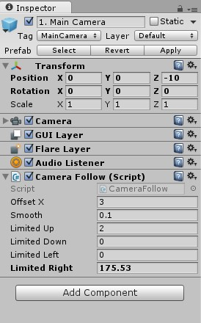**b. Main Camera**

The Camera use this script to follow the player, look at those parameters:

* + - * + **Offset X:** the X distance of player and the camera.
        + **Smooth:** how smooth the camera follow the player
        + **Limited Up, Down, Left, Right:** the limited position of the Camera, it can’t move out of that limited, you need to check and fill the **Limited Right**, it’s is the length of your level, over the Castle object.

1. 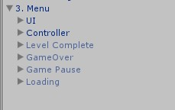**Menu**

*This is main GUI of game, it control all child in there:UI, GameOver, Game Pause, Level Complete,…*

*Place all items in it to setup correctly.*

1. **Controller:** Support for both Mobile and PC- **Mobile:**

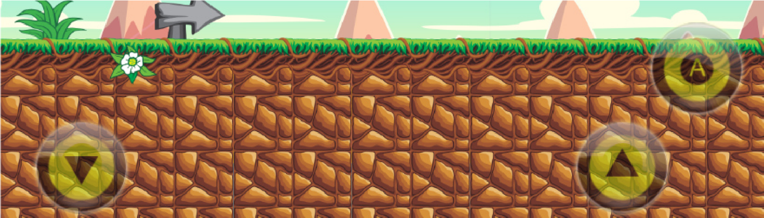

The Controller include 3 buttons: **Slide, Jump and Attack**

* + **PC:** you can change the keys in UI_Controller script
    - **Jump:** Arrow Up
    - **Slide:** Arrow Down
    - **Attack:** Arrow Right

**e.**

**Little Penguin**

**What he can does:**

jump, slide, throw bullet,

magnet to attract all star object and he has the

jetpack, that help him fly…………………….

**Speed:**

the speed of player

**Jump force:**

the force of jump

**Gravity Jump:**

Change the gravity of the

player to this value when it jump off the

ground.

**Gravity Slide:**

Change the gravity of the

player to this value when it slide on the

ground.

**Throw Force:**

the force when he throw the

bullet

**Jet Pack Force:**

the force move him up when

he uses the jet pack

**Throw Point:**

the position of bullet come out

**Smoke Point:**

the position of smoke, it must

be under his feet

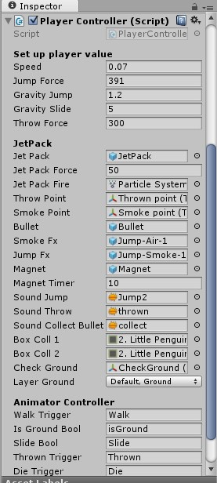

**Bullet, Smoke Fx, Jump Fx:** place the prefab in this **Magnet:** place the Magnet object in Penguin in this.

**Magnet Timer:** time before disable magnet

**Box Coll 1, Box Coll 2:** the upper collider of Penguin, it should be disabled when it slide to avoid collide with other object

**Check Ground:** the position check if the penguin on the ground to allow jump.

**Layer Ground:** pick up what are you consider the penguin be able jump if stand on it. **Animator Controller:** fill the parameters of Animator in this, it’s useful when you want to change to another player with different animations, just fill the event values in this and see how it works.

1. **Admob Ads:**

*Please download the Admob package then install it to this project, read the tutorial file in that folder to know how to integrate the admob.*

**Link: http://bit.ly/1ZxtkuL**

1. **Introduce Monsters and other things**

**1.**

**Monsters**

**a.**

**BOSS**

*He will attack you by drop the monsters from sky in*

*front of player.*

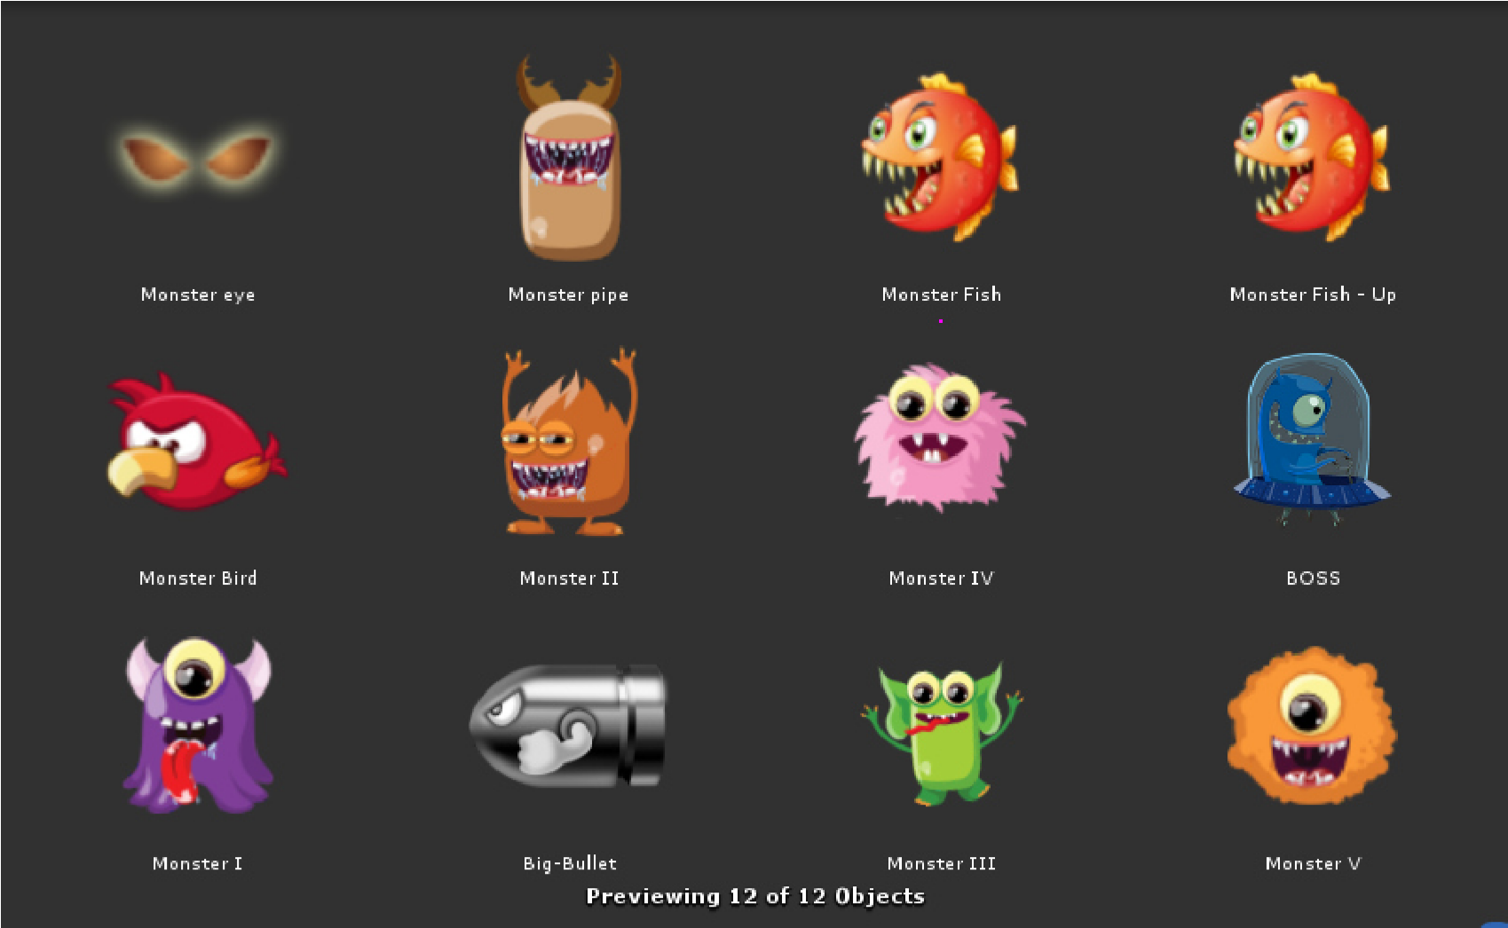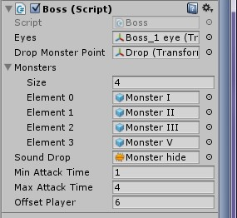

**Eyes:** The boss’s eyes, they will look at player

**Drop Monster Point:** the position drop monsters

**Monsters:** random choose the monster to drop in this list, you can add more

**Sound Drop:** play sound when drop monster

**Min Attack Time, Max Attack Time:** random choose the time between that value to delay before drop another monster

**Offset Player:** keep the distance with the player

**b.**

**Monster I**

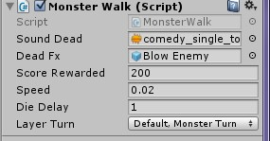

*He will moving when show up and change the direction when he hit other object in* ***Layer Turn****.*

*Note that the player can kill those Monster by Jump on their head or fire bullet on them.*

**Sound Dead:** play this sound when he get killed

**Dead Fx:** The smoke FX when he dead

**Score Rewarded:** add score when he dead

**Speed:** how fast can he moving

**Die Delay:** after the player jumped on his head, delay this time before he gone

**Layer Turn:** Which layer is consider the Monster will turn direction when collide with

**c.**

**Monster II**

*Same with Monster I*

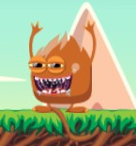

**d.**

**Monster III**

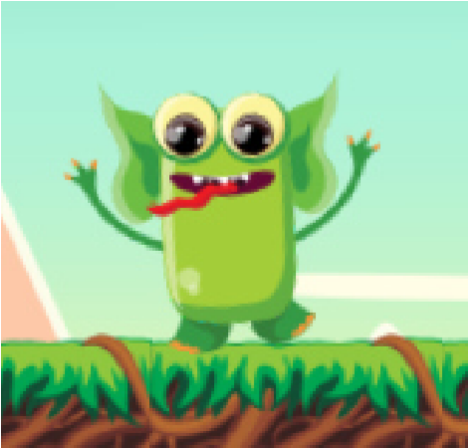

**e.**

**Monster IV**

*He will fall when the Detect Player detect the play*

*er*

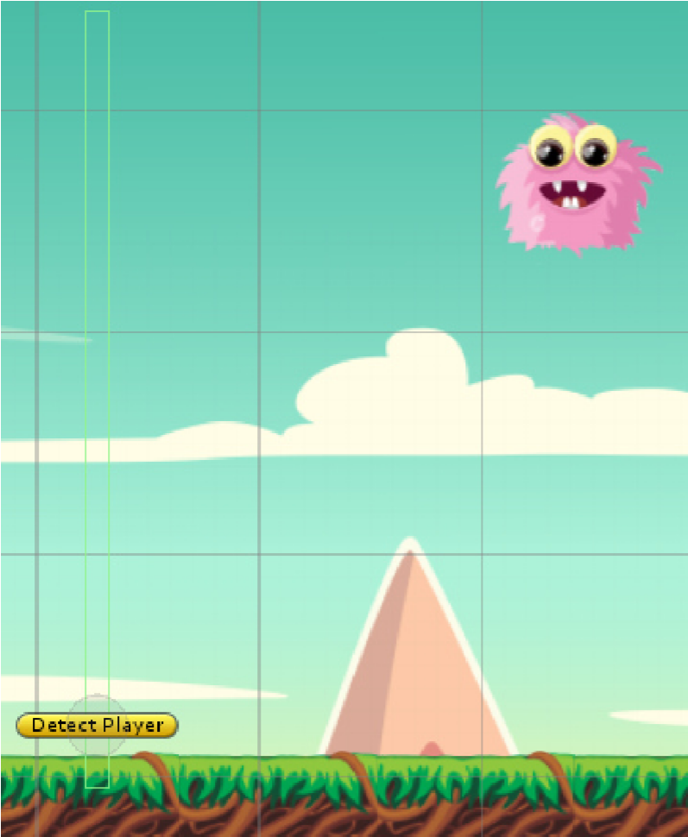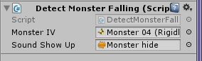

**Monster IV: Set the isKinematic to false to drop the monster down**

**Sound Show Up:** play this sound when he drop down

1. **Monster V**

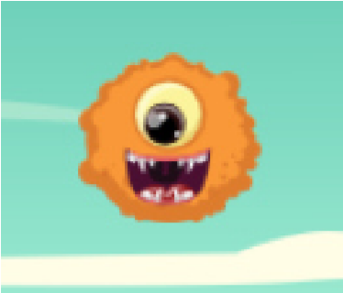

Same with Monster I,II,III but simple than them, no moving.

1. **Monster Bird**

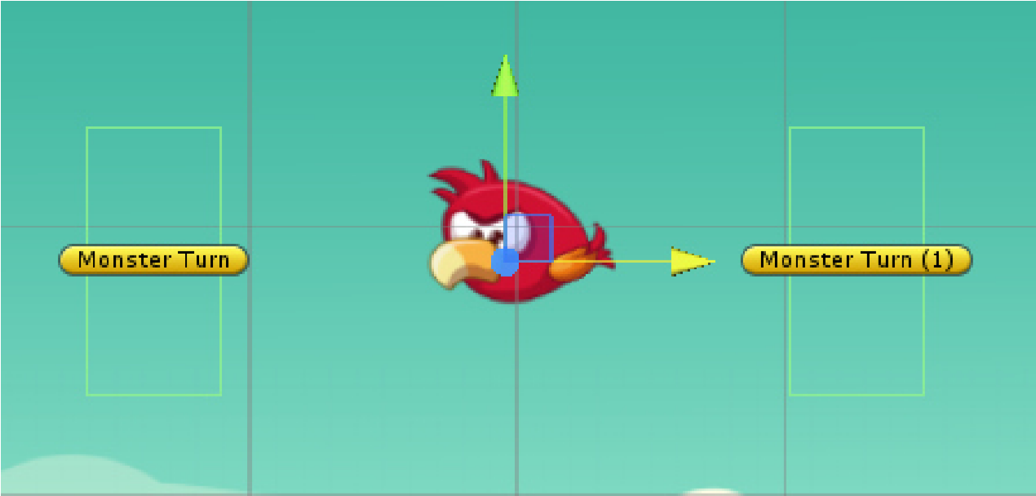

*He will fly on sky and change the direction when he catch the Monster Turn object*

*He uses MonsterWalk script as the same with Monster I,II and III*

**h.**

**Big Bullet**

*He attack the player with his power*

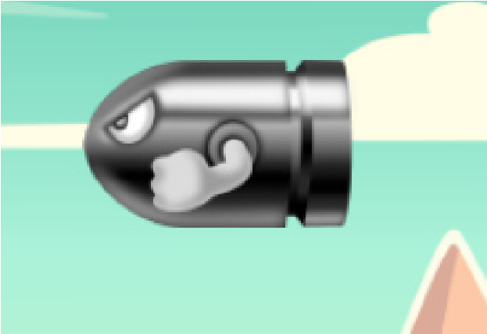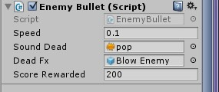

**Speed:** speed moving

**Sound Dead:** player can kill him by jump on his head, play this sound when he dead

**Dead Fx:** The smoke FX when he dead

**Score Rewarded:** add score when he dead

**i.**

**Monster Fish**

*He are waiting for you, when you get to his range,*

*he will jump on you suddenly*

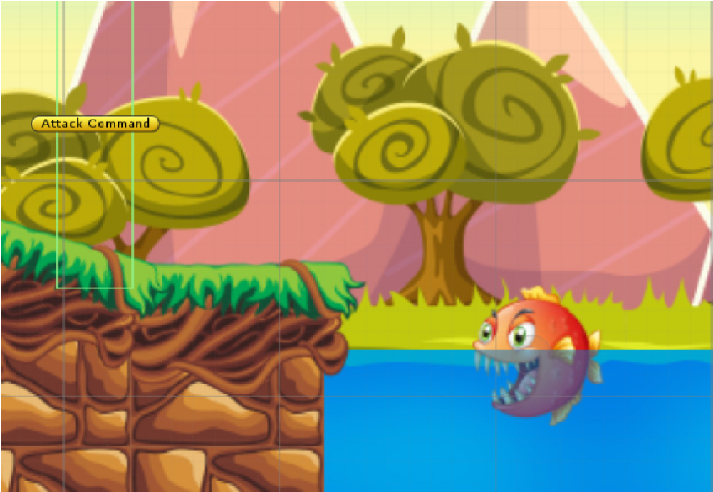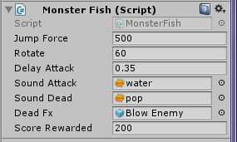

**Jump Force:** the force applied when he jump

**Rotate:** He will rotate 60” before he jump

**Delay Attack:** After he rotate 60”, he will wait this time before he jump out of the water **Sound Attack:** play when he jump

**Sound Dead:** play this sound when he get killed

**Dead Fx:** The smoke FX when he dead

**Score Rewarded:** add score when he dead

**j.**

**Block Monsters Hide**

*It is used a lot in this game. The aim is to detect*

*the player and enable the Monsters*

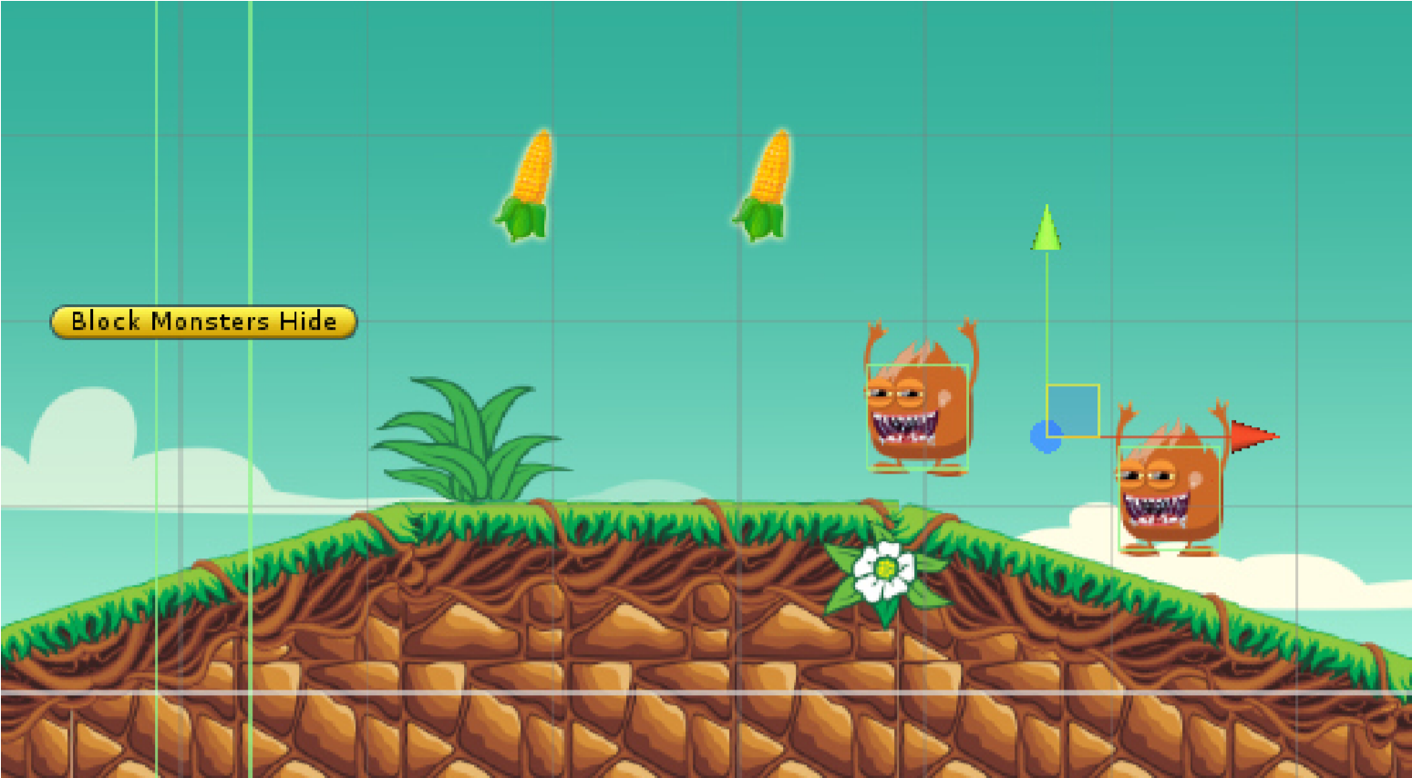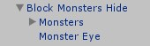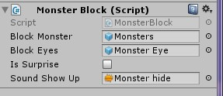

*object contains all monsters you place in it.*

**Block Monster:** place all monster you want to show up when player trigger with

Block Monster Hide

**Block Eyes:** place the Monster Eyes prefab in this object to make an effect about the location of the monsters – it’s optional

**Is Surprise:** play sound when the monsters show up or not

**Sound Show Up:** play when **Is Surprise** is true

**k. Monster Pipe**

*When player hit him, only way is die, so be becareful with this monster, just the bullet can kill him.*

**2. Some other things:**

**a.**

**Cannon**

*Auto rotate Up and Down when player get in side, th*

*en if user press any key or any*

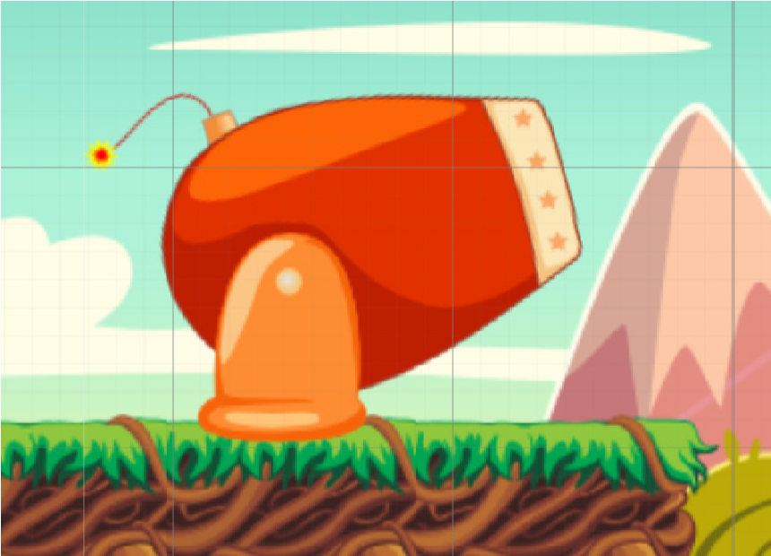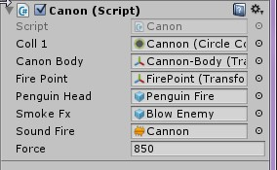

*touch on screen the Cannon will fire the player out with the given force*

**Cool 1:** the trigger of the cannon, disable this trigger when player get in side to avoid trigger again

**Cannon Body:** place the cannon body in here

**Fire Point:** the position fire the player

**Penguin Head:** enable player’s head, it’s just an image

**Smoke Fx:** spawn smoke when fire

**Sound Fire:** play sound when fire

**Force:** the force applied on player

1. **Stars**

Attract by the magnet, play animation when player collect

them

1. **Fruit**

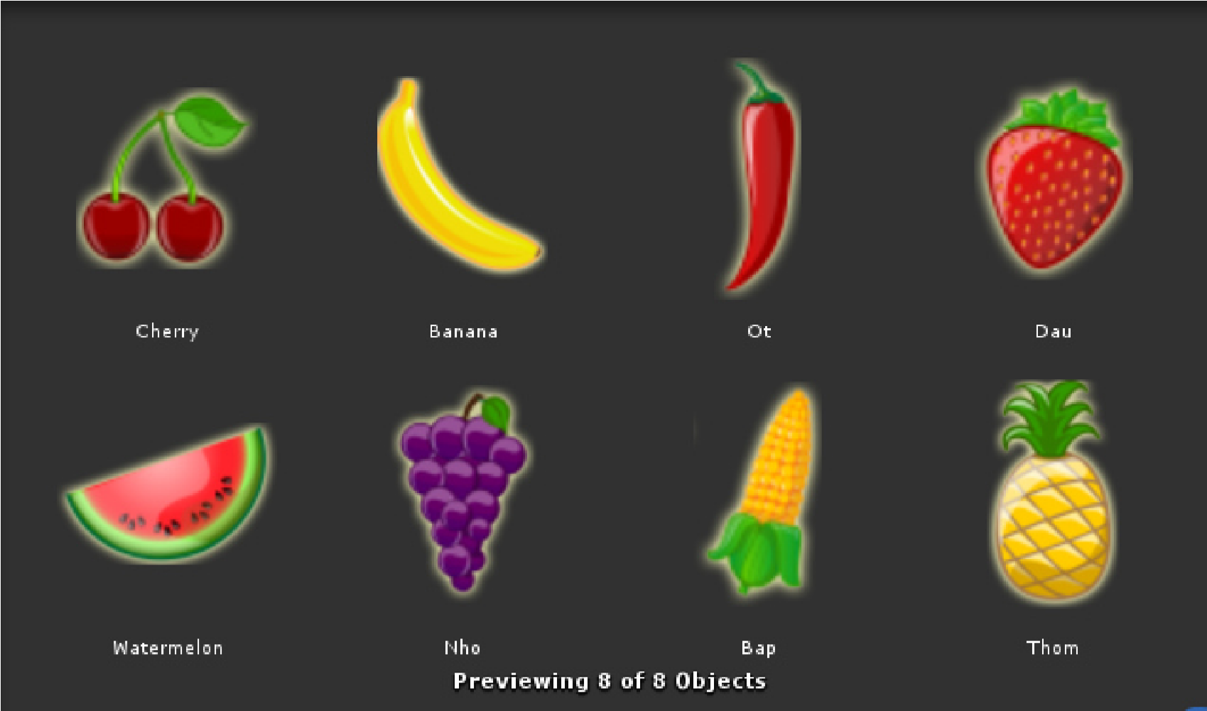

*Restore hearth for player, it’s very important! Player will be dead if not eat them*

1. **Magnet**

*When player collect this object, the magnet in his hand will be enable and attract the stars to player*

1. **Bullets**

*When player collect this object, the bullet will be added and player can throw the bullet by press A button.*

**f.**

**Springs**

*Push the player up when player jump on it*

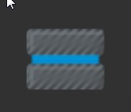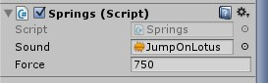

**Sound:** play when push the player

**Force:** the force applied to player

**g.**

**Bridge**

*Auto fall when player on it after delay time*

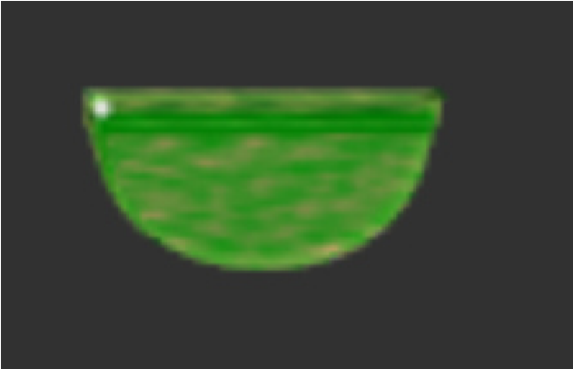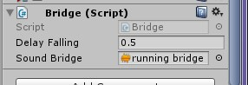

**Delay Falling:** the bridge will be fall after this delay time

**Sound Bridge:** play this sound when player on it

**h. HOW TO BUILD THE GROUND**

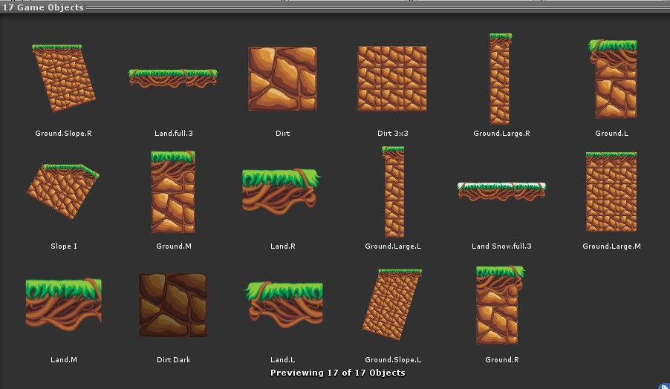

*You can find all the platform ground in Prefab/Platform/Ground*

*Note: use all of them to build a big ground, then parented to to one object and apply*

*Edge Collider on it and edit it to fit the ground*

*If you build a square ground you can use Box Collid*

*er to simple*

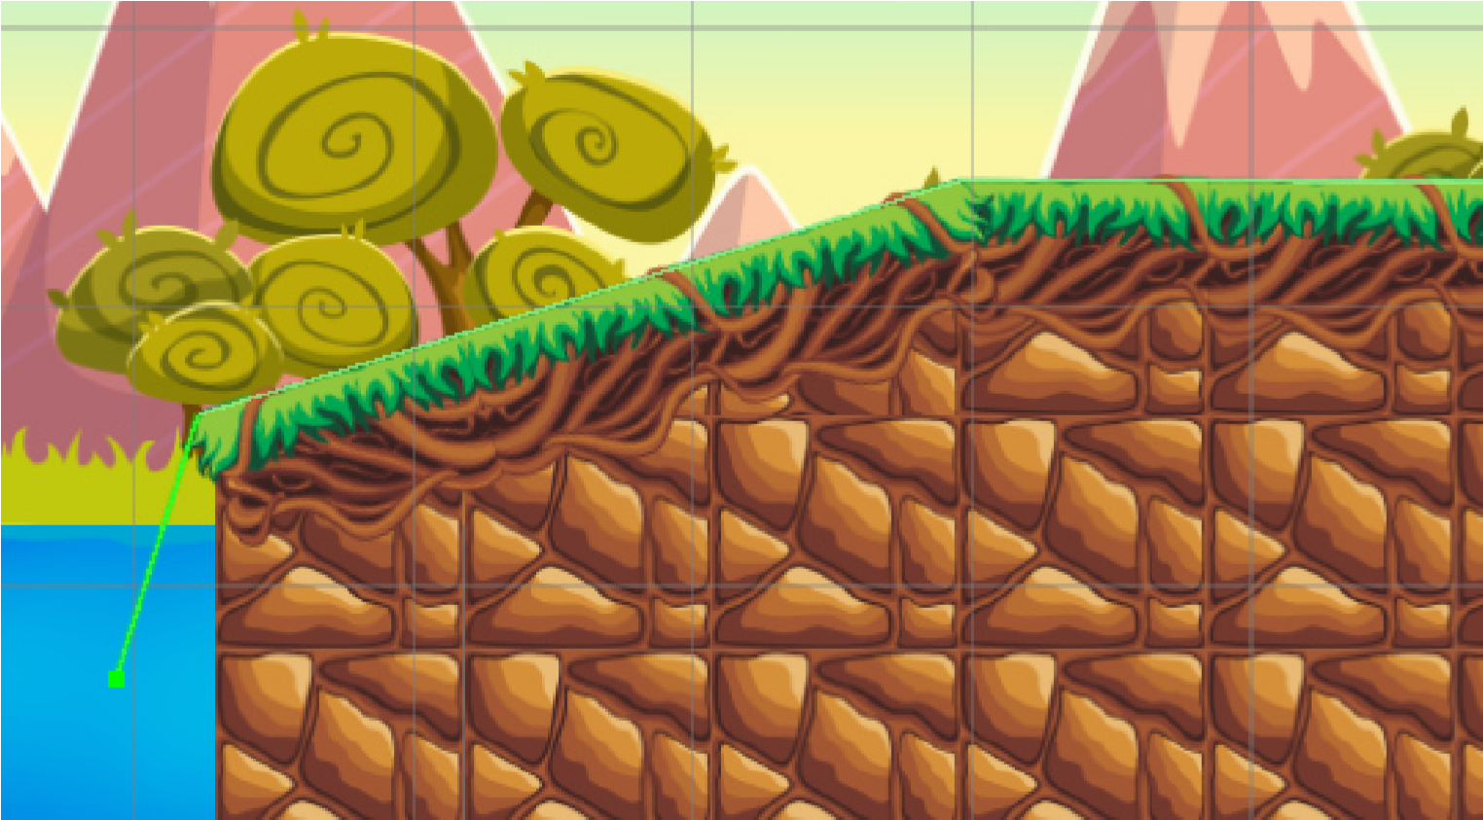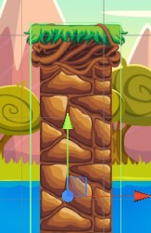

**5. Basic Tutorial**

***Please watch clip on youtube:***

***+ Full: https://www.youtube.com/watch?v=AOVESbmfEUU Parts:***

1. ***Create new ground: https://www.youtube.com/watch?v=0CMyKZz9v48***
2. ***Add Monsters: https://www.youtube.com/watch?v=YVlFWTX7ME4***
3. ***Add Castle- Finish level: https://www.youtube.com/watch?v=vIaCi-v2ox0***
4. ***Save scene level and add new level in Menu:***

***https://www.youtube.com/watch?v=7ku1T6B5lY4***

1. ***Add more block level: https://www.youtube.com/watch?v=39anVSN2VTw***
2. ***Go direct to Level panel: https://www.youtube.com/watch?v=LilULEF6JvA* Okay, That’s it! If you have any questions please contact me:**

**spfreecodeaz@gmail.com**

**Please review my game, I appreciate it!**

**Thank for your purchase! Good luck!**